SOLAR POWER BATTERY CHARGER

Introduction of the project

In today’s world, mobile phones have become an essential part of daily life, creating a constant demand for reliable and portable charging solutions.
Conventional charging methods rely heavily on electrical power, which may not always be available, especially in remote areas or during power outages. This has led to the growing need for alternative and sustainable energy sources.
Solar energy is one of the most abundant and renewable sources of energy available. It can be effectively utilized for small-scale applications such as
mobile phone charging. The use of solar power not only reduces dependency on conventional electricity but also promotes eco-friendly and cost-effective solutions.
This project focuses on the design and implementation of a solar-powered mobile phone charger using a 6V solar panel and a 7805 voltage regulator IC.
The system converts solar energy into electrical energy and regulates it to a stable 5V output suitable for charging mobile devices.
The project demonstrates the practical application of renewable energy and basic electronic components such as voltage regulators, capacitors, and PCB
design. It provides a simple, portable, and efficient solution for charging mobile phones using solar energy.

Introduction of each component

Solar Panel (6V, 100mA)
The solar panel is the main power source of the circuit. It converts sunlight into electrical energy using the photovoltaic effect. When exposed to sunlight, it produces a DC voltage of around 6V. However, the output is not constant and varies with light intensity, which is why voltage regulation is required before supplying it to a mobile device.

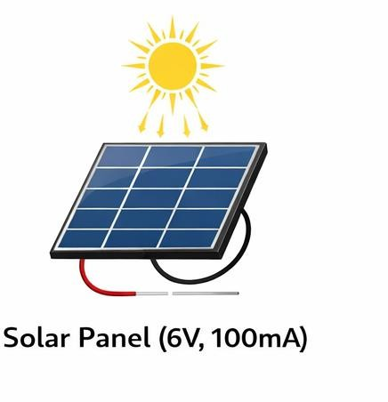

IC 7805 Voltage Regulator
The 7805 is a fixed linear voltage regulator that provides a stable 5V output. It takes an input voltage higher than 5V (typically 7V–20V, but works here due to low current conditions) and regulates it to a constant 5V. This is essential because mobile phones require a steady voltage for safe charging. It also protects the device from voltage fluctuations.

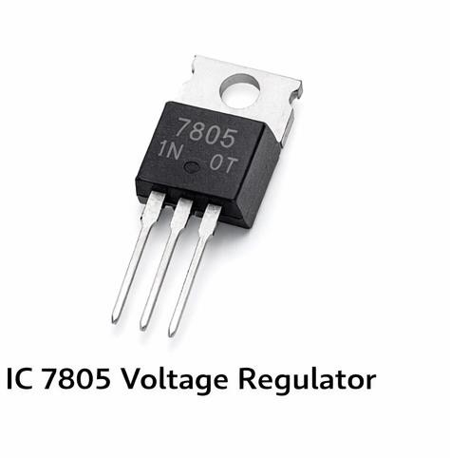

Capacitors
Capacitors are used for filtering and stabilizing the voltage in the circuit. An input capacitor (usually 0.33µF) reduces fluctuations from the solar panel, while an output capacitor (0.1µF) ensures a smooth and stable output from the regulator. They help in reducing noise and
improving the overall performance of the circuit.
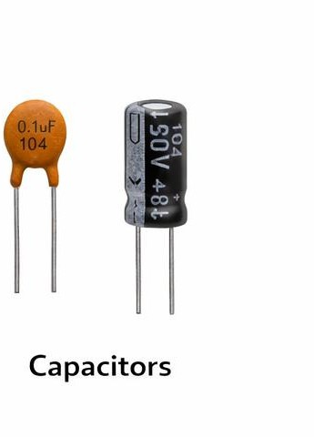

PCB (Printed Circuit Board)
The PCB is used to mount and interconnect all the electronic components in a compact and organized manner. It replaces loose wiring and ensures proper electrical connections through copper tracks. Using a PCB improves the durability, reliability, and neatness of the circuit.

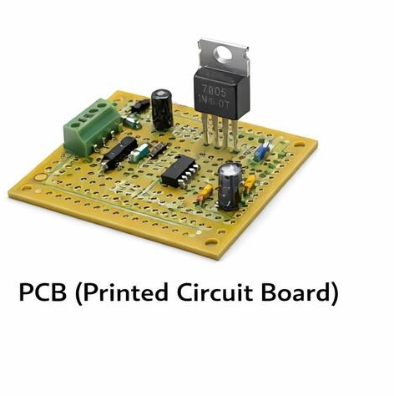

USB Cable / Output Port
The USB cable or port is used to transfer the regulated 5V output from the circuit to the
mobile phone. It provides a standard interface for charging devices and ensures compatibility with most smartphones.
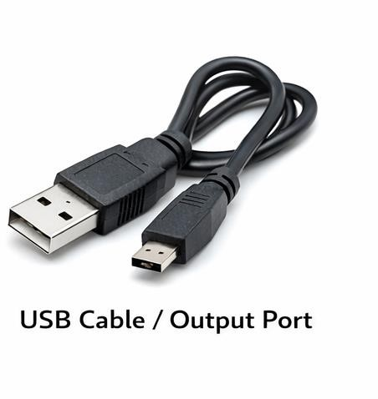

Jumper Wires
Jumper wires are used to make temporary or permanent electrical connections between components on the PCB. They are especially useful during testing and assembly of the circuit.

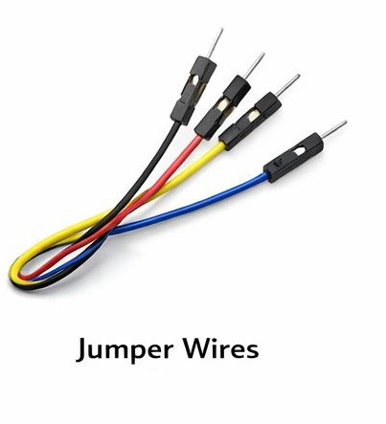

Diode (Optional but Recommended)
A diode is used to allow current to flow in only one direction. In this circuit, it prevents reverse current flow from the output side back to the solar panel, especially when there is no sunlight. This helps in protecting the components and improving efficiency.

Circuit Diagram
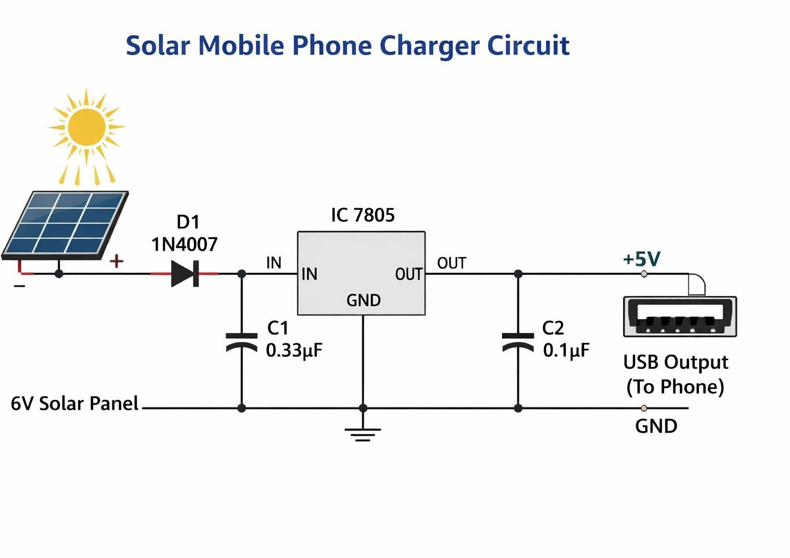

Principle

The working principle of the solar-powered mobile charger is based on the photovoltaic effect and voltage regulation.
The photovoltaic effect is the process by which solar cells convert sunlight into electrical energy. When sunlight falls on the semiconductor material of the solar panel, it excites electrons, creating a flow of electric current. This results in the generation of DC voltage at the output terminals of the solar panel.
However, the voltage produced by the solar panel is not constant and varies
depending on the intensity of sunlight. To ensure safe and reliable charging of mobile devices, this varying voltage must be regulated.
This is achieved using a 7805 voltage regulator IC, which maintains a constant output voltage of 5V regardless of fluctuations in input voltage (within its
operating range). Capacitors are also used to filter noise and smooth the voltage.
Thus, the project combines solar energy conversion and electronic voltage regulation to provide a stable power supply for mobile charging.

Working

The circuit begins with the solar panel, which generates approximately 6V DC when exposed to sunlight. This voltage is supplied to the input of the circuit.
A diode is often used in series with the solar panel to prevent reverse current flow, protecting the panel and other components when there is no sunlight.
The generated voltage is then fed into the 7805 voltage regulator IC. Since the solar panel output may fluctuate, the regulator ensures that the output remains constant at 5V.
Capacitors connected at the input and output of the regulator perform filtering functions. The input capacitor reduces variations from the solar panel, while the output capacitor stabilizes the regulated voltage and removes noise.
Finally, the regulated 5V output is supplied to the USB port, through which a mobile phone can be connected for charging.
When sufficient sunlight is available, the circuit operates effectively and provides continuous charging to the connected device.

Output

The output of the circuit is a regulated DC voltage of approximately 5V, which is suitable for charging mobile phones via a USB interface.
The current output depends on the solar panel rating. In this project, a 6V, 100mA solar panel is used, so the maximum current available is limited. Due to this, the charging process is relatively slow compared to conventional chargers.
The voltage regulator ensures that the output voltage remains stable even if the input voltage fluctuates due to changes in sunlight intensity. This protects the mobile device from damage caused by overvoltage.
Under good sunlight conditions, the circuit is capable of providing a steady output, but under low light conditions, the output may drop, affecting charging efficiency.

Applications

The solar-powered mobile charger has several practical applications, especially in situations where conventional electricity is not available.
It can be used in remote and rural areas where access to electrical power is limited. It is also useful during power outages as an emergency charging solution.
The charger is highly suitable for outdoor activities such as camping, trekking, and traveling, where carrying a portable power source is essential.
Additionally, it promotes the use of renewable energy, making it an environmentally friendly alternative to traditional charging methods. It can also be used as an educational project to demonstrate the practical application of
solar energy and basic electronics.
With further improvements, such systems can be expanded for larger-scale applications in sustainable energy solutions.

Limitations of the Project

- Low Output Current
The solar panel used (6V, 100mA) provides very low current, resulting in slow charging of mobile phones.
- Dependent on Sunlight
The circuit works only when sufficient sunlight is available. It performs poorly during cloudy weather, indoors, or at night.
- Voltage Drop Issues
The 7805 voltage regulator requires a higher input voltage (around 7V ideally), but the panel provides only ~6V, which may lead to unstable or reduced output.
- Low Efficiency of 7805
The 7805 is a linear regulator, which dissipates excess voltage as heat, reducing overall efficiency.
- No Energy Storage
The circuit does not include a battery, so it cannot store energy for later use.
- Not Suitable for Fast Charging
Modern smartphones require higher current (1A or more), which this setup cannot provide.
- Output Fluctuations
Changes in sunlight intensity can still affect performance despite regulation.
- Heating of Regulator
The 7805 IC may heat up during operation, especially if input voltage increases.
- Limited Practical Use
Suitable mainly for demonstration or small applications, not for regular daily charging needs.

Suggestions / Modifications

- Use a Higher Rating Solar Panel
Replace the 6V, 100mA panel with a higher current panel (e.g., 6V–9V, 1A or more) to achieve faster and more efficient charging.
- Add a Rechargeable Battery
Include a battery (like a Li-ion cell) to store energy so that the charger can be used even when sunlight is not available.
- Replace 7805 with a Buck Converter
Use a switching voltage regulator (DC-DC buck converter) instead of 7805 to improve efficiency and reduce power loss as heat.
- Add Charging Indicator LED
Incorporate an LED to indicate when the device is charging or when sufficient power is available.
- Use a Voltage Booster Circuit (if needed)
If input voltage is low, a boost converter can be added to maintain a proper 5V output.
- Include Protection Circuits Add protection features like:
  - Overvoltage protection
  - Short-circuit protection
  - Reverse polarity protection

